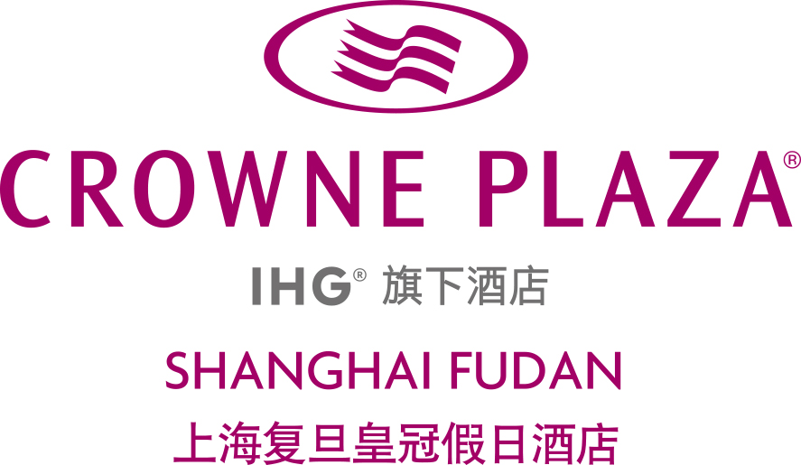
Block Code: ICC
Hotel Registration Forms for ICCM 2024
2nd Jan–6th Jan 2025
Kindly Email the appropriate form directly to the Hotel.
Crowne Plaza Shanghai Fudan
Mr. Jamison Chen / Account Director
Tel: 86 21 5222 9999 ext. 3005 Fax: 86 21 5222 9995
Address: 199 Handan Road Shanghai PRC
HOTEL RESERVATION FORM  Crowne Plaza Shanghai Fudan  Reservations may be made by completing this  form and returning it by fax to reservation department of  Reservation Department, fax no. 86 21 5552 9996 or email to reservations@crowneplazafudan.com & jamison.chen@crowneplazafudan.com, by the deadline of Jan. 30th 2024. Thereafter, reservations at the special conference rate can only be confirmed subject to availability. Crowne Plaza Shanghai Fudan will send a written confirmation upon receipt of this completed form.  Arrival Date: __________________________  Departure Date: ______________________  Name: __________________ ______________  Mr./Ms. Last First  TEL: ____________________________  E-Mail: __________________________  Room category Room Rate  Superior Room □ CNY800net  Deluxe Room □ CNY950net  Suite Room □ CNY1,250net  Bedding type □ King Bed  □ Twin bed |  | The room rates are inclusive of 6% government tax and 10% service charge; free guest room internet service; including one or two daily buffet breakfast per room per day. Additional buffet breakfast at CNY80net.  The room rates are applicable to 3 days prior to group arrival date and 3 days latter to group departure date.  AIRPORT TRANSPORT SERVICE:  Arrival Flight #: _________________________  Departure Flight #: _______________________  □ Limousine at CNY500 per car per trip.  (From/to Hongqiao Airport)  □ Limousine at CNY650 per car per trip.  (From/to Pudong International Airport)  PAYMENT:  I will guarantee my reservation with:  □Visa □ Master Card □Diners Club  □JCB □American Express  Credit Card No.: _________________________  Expiration Date: _________________________  **One night room rent will be charged in the event of cancellation with less than 48 hours notice or  NO-SHOW.  Signature: ______________________________  Date: __________________________________

